H2 | ANDERSON SERANGOON JUNIOR COLLEGE  HIGHER 2
CANDIDATE  NAME |  | MARK SCHEME
CLASS |  | 2 | 1 | / |  |  |  |  | INDEX NUMBER

BIOLOGY 9744/04

Paper 4 Practical 1 September 2021
Wednesday

2 hours 30 minutes
Candidates answer on the Question Paper.
Additional Materials: As listed in the Confidential Instructions.

READ THESE INSTRUCTIONS FIRST

Write your name, class and index number on all the work you hand in.
Give details of the practical shift and laboratory, where appropriate, in the boxes provided.
Write in dark blue or black pen.
You may use an HB pencil for any diagrams or graphs.
Shift
Laboratory
Do not use staples, paper clips, glue or correction fluid.

Answer all questions in the spaces provided on the Question Paper.

The use of an approved scientific calculator is expected, where appropriate.
You may lose marks if you do not show your working or if you do not use appropriate units.

At the end of the examination, fasten all your work securely together.
For Examiner’s Use
1 | 22
2 | 11
3 | 22
Total | 55
The number of marks is given in brackets [ ] at the end of each question or part question.

This document consists of 23 printed pages and 1 blank page.
 | Answer all questions.
1 | Invertase is an enzyme found in honey.  Invertase breaks down sucrose (non-reducing sugar) into reducing sugars, as shown:  invertase  sucrose reducing sugars  In this investigation, you will determine the concentration of invertase in a sample of honey.  The presence of reducing sugars can be detected by using Benedict’s solution. The time taken for the Benedict’s solution to first show a colour change can be used to estimate the concentration of invertase in the honey extract, H.  You will need to prepare a serial dilution of 1.0% invertase solution, E.  You are provided with:  - honey extract solution, in a specimen tube labelled H  - 1.0% invertase solution, in a specimen tube labelled E  - Benedict’s solution, in a specimen tube labelled B  - 5% sucrose solution, in a specimen tube labelled S  - distilled water, in a specimen tube labelled W.  Honey extract solution H, 1.0% invertase solution E and Benedict’s solution B are irritants. Suitable eye protection should be worn. If H, E or B comes into contact with your skin, wash it off immediately under tap water.
 | (a) | You will need to carry out a serial dilution of the 1.0% invertase solution, E, to reduce the concentration of invertase by a factor of 10 between each successive dilution.  After the serial dilution is completed, you will need to have at least 5 cm³ of each concentration available for use.
(i) Complete Fig. 1.1 to show how you will dilute E.

For each beaker:

- state, under the beaker, the volume and concentration of invertase solution available for use in the investigation, after the serial dilution has been completed

- use one arrow with a label, above the beaker, to show the volume and concentration of invertase solution added to prepare the concentration

- use another arrow with a label, above the beaker, to show the volume of W added to prepare the concentration.

………. cm³ of 1.0 % invertase solution, E

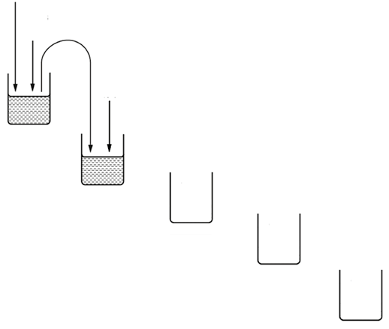
0 cm³ of W
………. cm³ of 1.0 % invertase solution, E

………. cm³ of W

………. cm³ of 1.0 % invertase solution, E, left to use

………. cm³ of ………. % invertase solution left to use

Fig. 1.1

- correct concentrations under remaining 4 beakers, i.e. 0.1, 0.01%, 0.001%, 0.0001% (and) invertase solution to use [P]
- correct volumes indicated, i.e. [MMO]
  - initial volume of 10.0 cm³ of E added, followed by subsequent transfer of 1.0cm³ of invertase solution from previous to next beaker
  - 9.0 cm³ of each invertase solution (left) to use.
  - 9.0 cm³ of W added into each beaker
- All volumes indicated to 1 dp [PDO]

[3]
Before proceeding further, use the beaker labelled hot water to collect approximately 200 cm³ of hot water from where it is provided in the laboratory.

The beaker labelled tap water can be filled as necessary from the tap.

 | Proceed as follows.
 | 1 |  | Prepare the concentrations of invertase solution as you decided in (a)(i) and shown in Fig. 1.1. Use a glass rod to mix the invertase solutions and water.
 | 2 |  | Set up a water-bath at a temperature of approximately 30°C, using hot water and tap water. Sufficient water should be used to ensure that the contents of the test-tubes will be covered in step 8.
 | 3 |  | Label test-tubes with the concentrations of invertase solution prepared in step 1.
 | 4 |  | Put 2 cm³ of each concentration of invertase solution into an appropriately labelled test-tube.
 | 5 |  | Label another test-tube H.
 | 6 |  | Put 2 cm³ of honey extract, H, into the test-tube labelled H.
 | 7 |  | Put 2 cm³ of S into each labelled test-tube, including the test-tube labelled H.
 | 8 |  | Put all of the test-tubes into the water-bath at approximately 30°C. Incubate the test-tubes in the water-bath for 10 minutes. During this 10-minute period, you do not need to maintain the temperature of the water-bath.
 |  |  | During this incubation period, use the time to continue with question 1.

 | 9 |  | After the 10-minute incubation period in step 8, remove the test-tubes from the water-bath and put them in a test-tube rack.
 | 10 |  | Put 4 cm³ of Benedict’s solution, B, into each of the test-tubes.
 | 11 |  | Heat the water-bath to boiling using a Bunsen burner, and then stop heating. Sufficient water should be used in this water-bath to ensure that the contents of the test-tube will be covered in step 12.
 | 12 |  | Put the test-tube labelled H into the water-bath. Start timing.
 | 13 |  | Measure the time taken to the first colour change. Record the result in (a)(ii).  If there is no colour change after 3 minutes, record the result as ‘more than 180’.
 | 14 |  | Repeat step 12 and step 13 using each of the concentrations of invertase solution you prepared in step 1, instead of H. Record your results in (a)(iii).
 |  |  | (ii) | State the result for H.
- time for H recorded, to nearest s [MMO]
Note: time taken should be (approximately) same as that of 0.1% invertase

........................................................................ seconds [1]
 |  |  | (iii) | Use the space below to record your results from step 14 in a suitable format.
- correct heading for independent variable, i.e. invertase concentration and % [PDO]
- correct heading for dependent variable, i.e. time taken for first colour change and s (R: seconds/ sec/ min and s) [PDO]
- correct trend, i.e. shortest time for 1.0% invertase to longest time (“more than 180”) for lowest invertase concentration (Note: [MMO]
- readings for five invertase concentrations, to the nearest s [MMO]

[4]
 |  |  | (iv) | Use your results from (a)(ii) and (a)(iii) to estimate the concentration of invertase in H.
- correct interpretation from table [ACE]

Note: result for H should be similar/ the same as 0.1% invertase

concentration of invertase in H = ..................................................... % [1]

Confidence in the results of this investigation may be limited by lack of replication and sources of error.

One possible source of error in this procedure is that temperature is not controlled in step 8 and steps 12 – 14.
 |  | (v) | Explain why it is not necessary to maintain the water bath at 30°C in step 8. [1]
 |  |  | - Ref. to lack of control of water bath temperature being a systematic error, e.g. all test-tubes were in the same water bath in step 8, any temperature change would have equally affected all tubes/ OWTTE [ACE]
 |  | (vi) | State two other significant sources of error in this procedure that would prevent an accurate estimate of the invertase concentration in H.  For each source of error, suggest one modification to the procedure in order to obtain a more accurate estimate of the invertase concentration in H. [4]
- first colour change was difficult to determine/ difficult to ensure to be the same across tubes/ determination of first colour change is subjective across tubes as it is done by the naked eye
- measuring mass of precipitate formed after a fixed time interval/ film the experiment and watch playback to review exact moment of colour change/ have at least one other person to identify first colour change independently and compare results

- as one tube was being tested from steps 12-14, invertase would still be digesting sucrose in the other tubes
- ref. to staggered start/ completing experiment for each concentration before moving on to next/ boiling all tubes before step 10 (to denature invertase)

[if answer for (a)(iv) is given as a range, i.e. does not match one of the standard invertase concentrations]
- intervals between invertase standards are too wide
- use concentrations of invertase solution within a narrower range either side of estimated concentration of H/ decrease the interval between each concentration e.g. instead of 1:10 dilution, use a 1:4 dilution. (R: use simple dilution for equal intervals)

R: not conducting repeats, errors related to temperature, pH

[ACE]

 | (b) | A student proposes to modify the experiment by measuring the amount of sucrose left.  This modified procedure involves two additional steps after step 9 and before resuming with step 10.
 |  | (i) | Outline the two additional steps, including any named reagent(s) required. [1]
- first additional step: add 2.0 cm³ (or appropriate vol.) of HCl/ acid to sample in a test tube, and heat in a boiling water bath

- second additional step: Allow mixture to cool, and add a small excess of NaHCO₃/ base
[P]
 |  | (ii) | Evaluate briefly whether the student’s modified procedure will produce more accurate results, compared to the original procedure. [1]
- No + ref. to all tubes would contain reducing sugars (products of sucrose breakdown) that would cause colour change when subsequently heated with Benedict’s solution
[ACE]

 | (c) | Honey contains a mixture of sugars. The percentage concentration of these sugars changes over time.  The percentage concentration of sucrose in honey was measured for a period of 25 weeks.  The results are shown in Table 1.1.  Table 1.1
  storage time  / weeks | percentage concentration of  sucrose
  0 | 2.3
  3 | 1.8
  6 | 1.3
  12 | 0.9
  25 | 0.5
 |  | (i) | Use the grid provided to display the results shown in Table 1.1.
 | 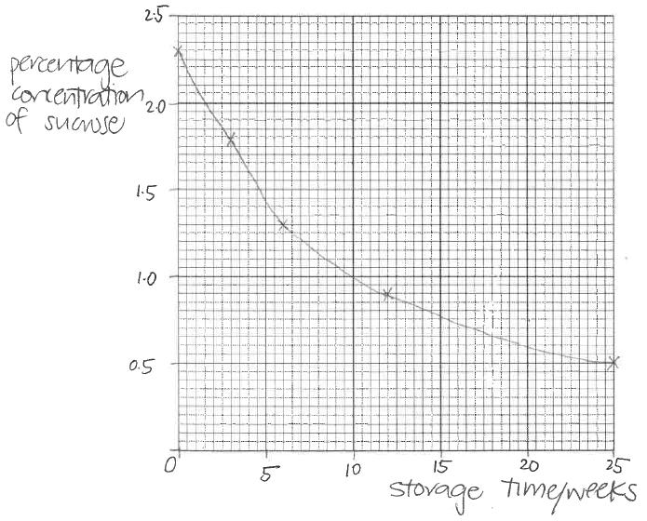 |  | - correct axes: x-axis - storage time/ weeks and y-axis - percentage concentration of sucrose  - correct scale: x-axis - 5 (weeks) to 10 small squares, y-axis - 0.5(%) to 10 small squares  - correct plotting of all points using small crosses or dots in circle  - points joined with a thin line passing through all points as either a line (curve) of best fit or straight ruled lines joining each point to the next  [PDO]  [4]

 |  | (ii) | With reference to your graph in (c)(i), state the estimated percentage concentration of sucrose at 15 weeks of storage.  Show on your graph in (c)(i) how this estimate is made.
 |  |  | - dotted lines shown on graph + correct reading off from graph drawn (e.g. 0.75 %) [MMO]
 |  |  | percentage concentration of sucrose = ..................................................... [1]
 |  | (iii) | Use biological knowledge to explain the key difference in the change in sucrose concentration between 0-15 and 15-25 weeks of storage. [1]
 |  |  | - ref. to sucrose/ substrate concentration is (increasingly) limiting in 15-25 weeks of storage (ORA) [ACE]
 |  |  | [Total: 22]

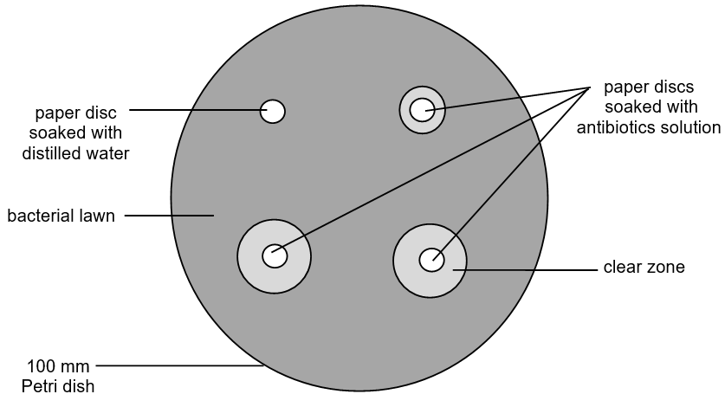  2 | The disc diffusion method is used to test the effectiveness of antibiotics.  In the disc diffusion test, Petri dishes containing nutrient agar are inoculated and incubated with bacteria cells to produce an evenly distributed growth of the bacteria known as a bacterial lawn. Paper discs soaked with antibiotics are then placed on top of the agar before a lid is placed on the Petri dish. The Petri dish is then incubated overnight for 24 hours.  Fig. 2.1 shows a sample result of a disc diffusion test after incubating the Petri dish for 24 hours.  Fig. 2.1  The clear zones around the discs soaked with antibiotics solution showed that the bacteria cells had been killed, while none had been killed by the distilled water.  Clear zones of a larger diameter indicate a more effective killing of bacteria cells by the antibiotic.

Urinary tract infection (UTI) is an infection in any part of the urinary system which includes the ureter, bladder and urethra.

Five different drugs (cephalexin, trimethoprim, co-amoxiclav, ampicillin and ciprofloxacin) are commonly used antibiotics used to treat urinary tract infections by killing the Escherichia coli (E. coli) bacteria which is the main cause of infection.

A student conducted the disc diffusion test to find out which drug is the most effective antibiotic to treat UTIs and obtained the results shown in Fig. 2.2.

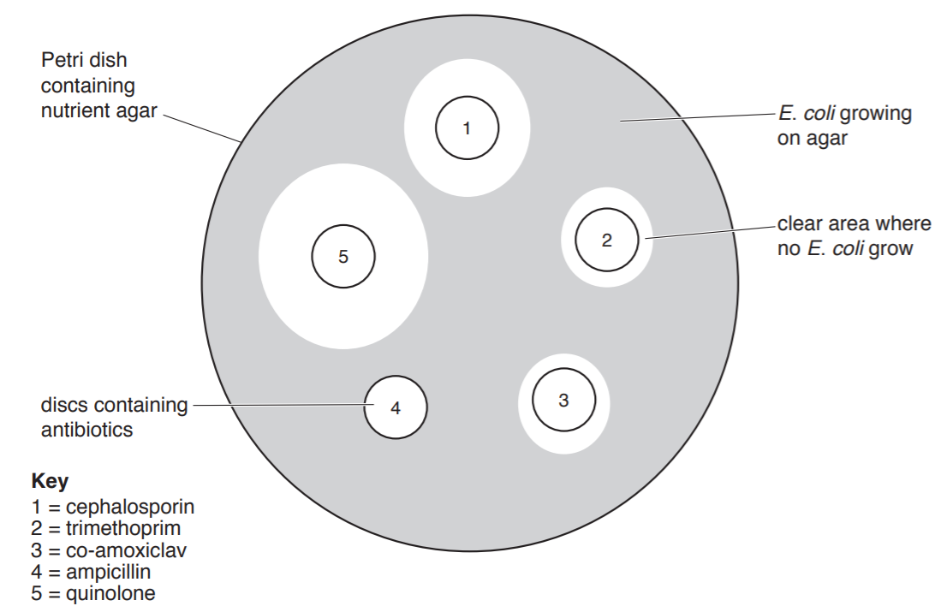
1 = cephalexin
2 = trimethoprim
3 = co-amoxiclav
4 = ampicillin
5 = ciprofloxacin
Fig. 2.2

 | (a) | State the independent variable for this experiment. [1]
 |  |  | - type of antibiotic/drug

 | (b) | Using the information provided, plan a method that could have been carried out by the student to obtain the results in the Petri dish shown in Fig. 2.2.  Do not plan to carry out repeats.  You must use:  - 10 cm³ of 10% cephalexin  - 10 cm³ of 5% trimethoprim  - 10 cm³ of 1% co-amoxiclav  - 10 cm³ of 1% ampicillin  - 10 cm³ of 1% ciprofloxacin  - 200 cm³ of distilled water  - filter paper sheets  - hole puncher  - marker pen  - prepared 100 mm diameter agar plate, with a lawn of E. coli  - sterilising solution (disinfectant) and paper towels  You may select from the following sterilised apparatus and plan to use appropriate additional apparatus:  - normal laboratory glassware, e.g. beakers, measuring cylinders, graduated pipettes, glass rods, syringes, etc.  - incubator  - sticky tape (parafilm)  Your plan method should:  - have a clear and helpful structure so that the method described could be repeated by anyone reading it  - include details to ensure that the results are as accurate and repeatable as possible  - use the correct technical and scientific terms  - make use of the apparatus and materials stated.  [7]
- [Aseptic technique] Using disinfectant (sterilising) solution and paper towels, wipe the work area. [compulsory – 1m]
- Use the hole puncher to create at least 5 paper discs from the filter paper. [compulsory – 1m]
- Carry out simple dilution of 10% cephalexin and 5% trimethoprim solutions to obtain 1% concentration in a 20mL beaker, according to the table below. [compulsory – 1m]

Antibiotic solution | Volume of antibiotic solution used  / cm³ | Volume of distilled water used / cm³ | Total volume / cm³
10% cephalexin | 1.0 | 9.0 | 10.0
5% trimethoprim | 5.0 | 5.0 | 10.0
Correct values in dilution table – 1m
- Pour 10cm³ of each antibiotic solution into a beaker/base of petri dish.
- Soak one paper disc in each of the 5 antibiotic solutions and remove after 5 minutes. Time with a stopwatch. [compulsory – 1m]
- Draw lines on the base of the prepared 100 mm diameter agar plates using a marker so that the base is split into five equal parts. Label the sections 1 to 5.
- [Aseptic technique] Turn on the bunsen burner. Put the agar plate near the flame.
- Place the paper discs soaked with the different antibiotics solutions onto the agar plate, 1 disc in each section. [compulsory – 1m]

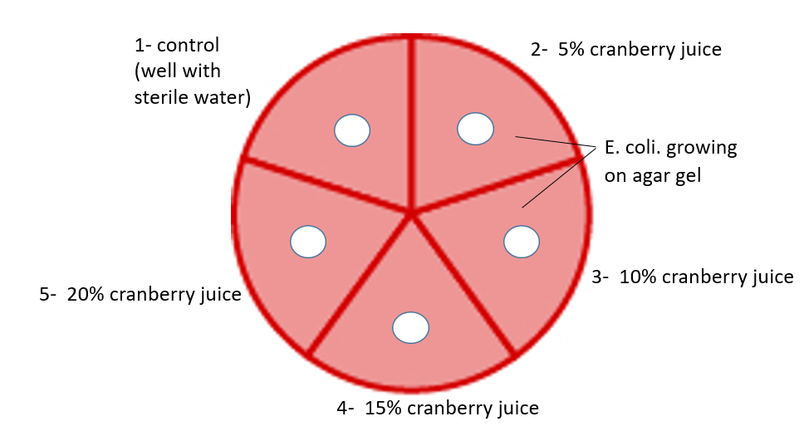

- Seal the petri dish using sticky tape (parafilm) and incubate the petri dish at 30°C in an incubator overnight for 24 hours. [compulsory – 1m]

 | (c) | Drug effectiveness can be determined by the area of the clear zone, which is a ring of no bacterial growth around the paper disc. The student proceeded to measure the diameter of the clear zones around the five paper discs to determine their areas and tabulated his results in Table 2.1.  The area of a circle is given by the equation shown.  Area of circle = πr²  π = 3.14  r = radius of circle  Table 2.1
  Paper disc | Diameter of paper disc / mm | Diameter of clear zone / mm | Area of clear zone / mm²
  1 | 4 | 8 | 37.7
  2 | 4 | 6 | 15.7
  3 | 4 | 6 | 15.7
  4 | 4 | No clear zone
  5 | 4 | 11 | 82.4
 |  | (i) | Complete Table 2.1 to show the appropriate unit and calculated values for the areas of the clear zones. [2]
- Correct unit + values to 3 sf –1m
- Correct calculation of 4 values, to 3sf – 1m

 |  | (ii) | Based on Fig. 2.2 and Table 2.1, state the most effective drug that can be used to treat UTIs. Explain your answer. [1]
- Ciprofloxacin
- Ref. to antibiotic/drug that gives the largest zone of clearance (at the same concentration) which indicates killing of most bacteria cells at the same concentration.

 |  |  | [Total: 11]

3 | J1 is a slide of a stained transverse section through a plant root.  You are not expected to be familiar with this specimen.
 | (a) | Use your microscope to observe the different tissues of the root on slide J1.  In the space below, draw a plan diagram of part of the root on slide J1, as shown in the shaded area of Fig. 3.1. A plan diagram only shows the arrangement of different types of tissues, including their correct shapes and proportions. Individual cells must not be drawn in plan diagrams.  Use one ruled label line and label to identify the epidermis.  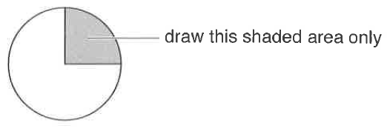  draw this shaded area only  Fig. 3.1
J1 is TS Maize root
Award 1 mark for drawing quality:  - Clear continuous lines with no shading and no individual cells drawn; | 1
Award 1 mark for each of the following:  - Structures drawn in correct proportion showing correct distribution of tissues  - Good to draw a quadrant outline first.  - Ratio of cortex: pith = ~ 1: 1 or 1: 1.3  - Pls also note the distribution of the xylem and phloem (next page). Note that the distribution is not like this (this distribution is for the stem):  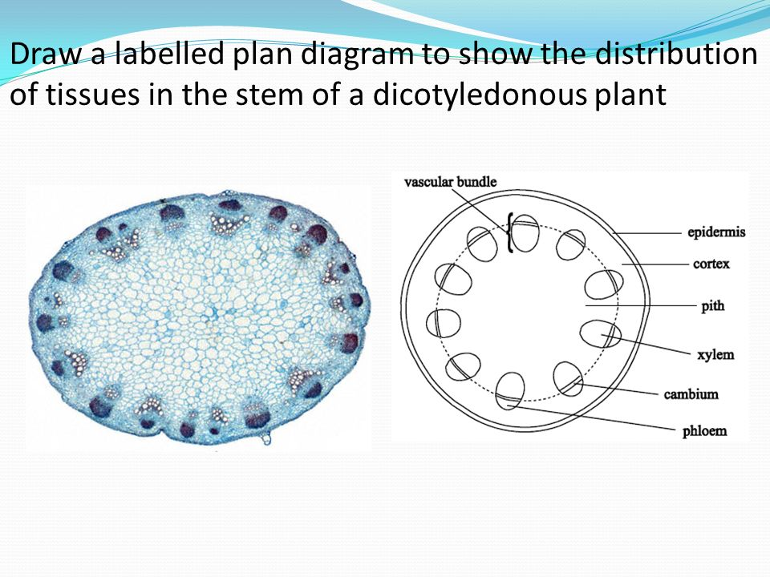  - Epidermis correctly labelled (label lines should be arranged neatly, drawn with a ruler, and end within structure) | 1  1

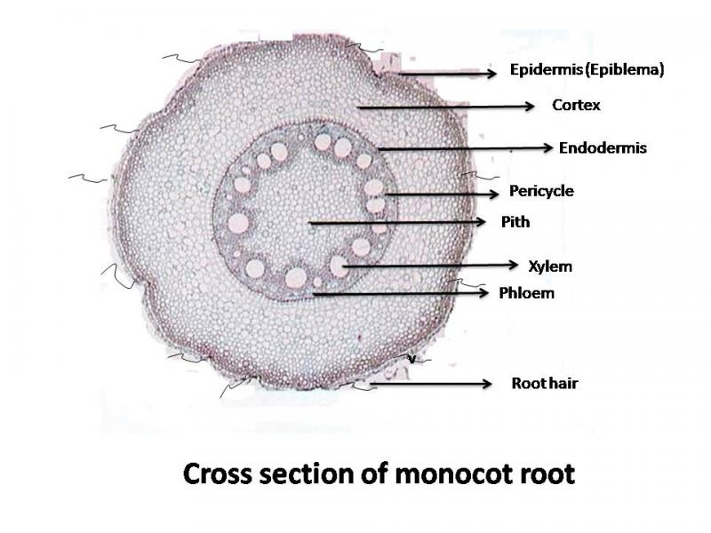
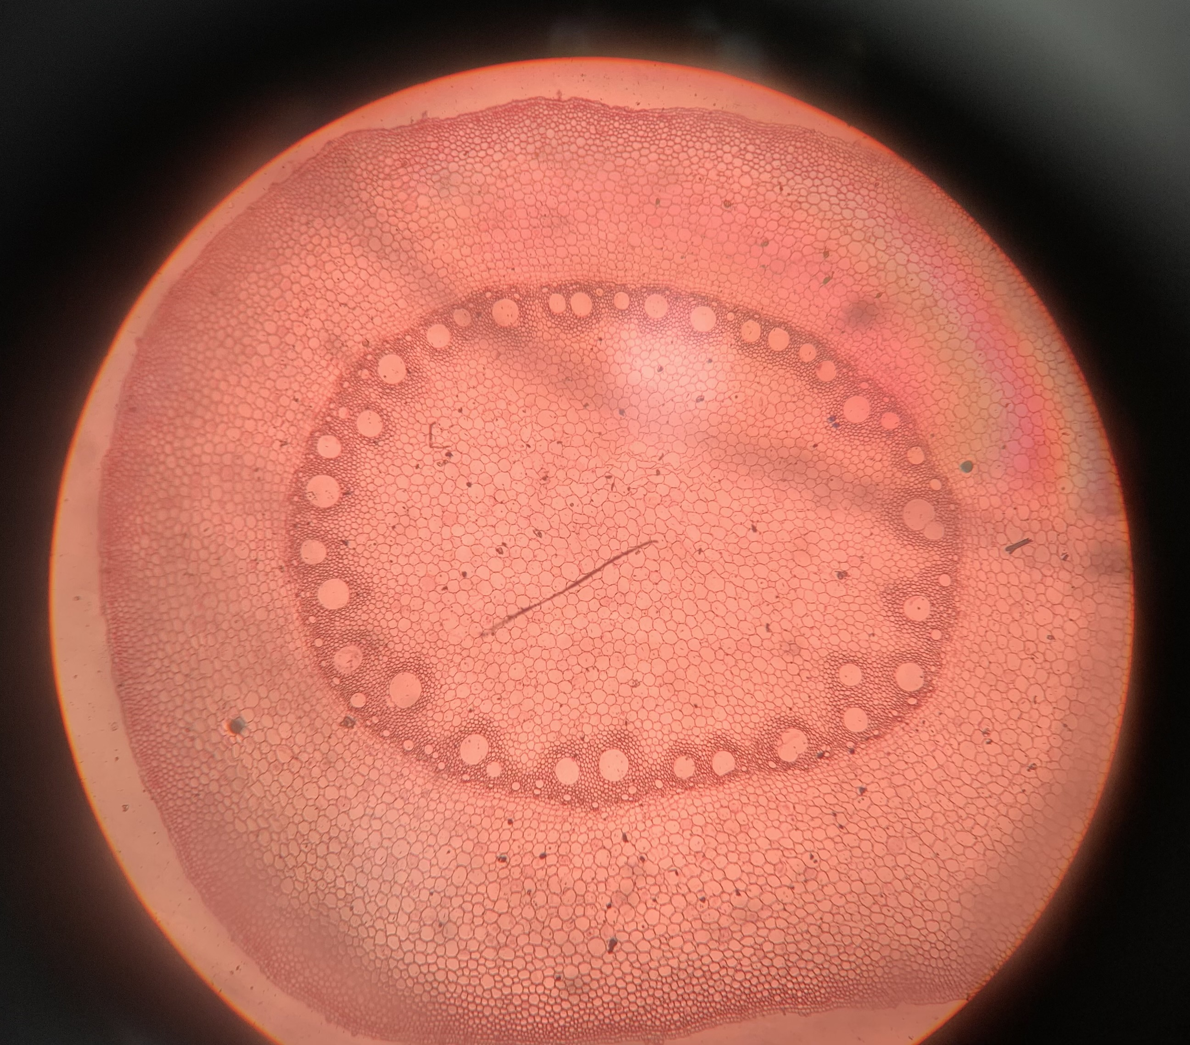

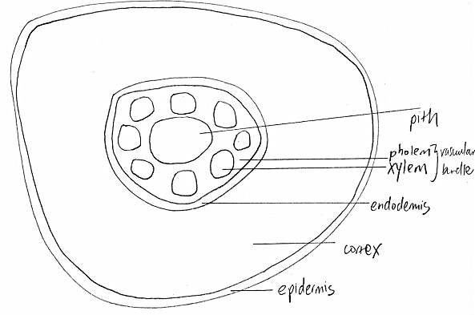

[MMO] [3]

(b) | Fig. 3.2 is a photomicrograph of a stained transverse section through a root of a different type of plant.  You are not expected to be familiar with this specimen.
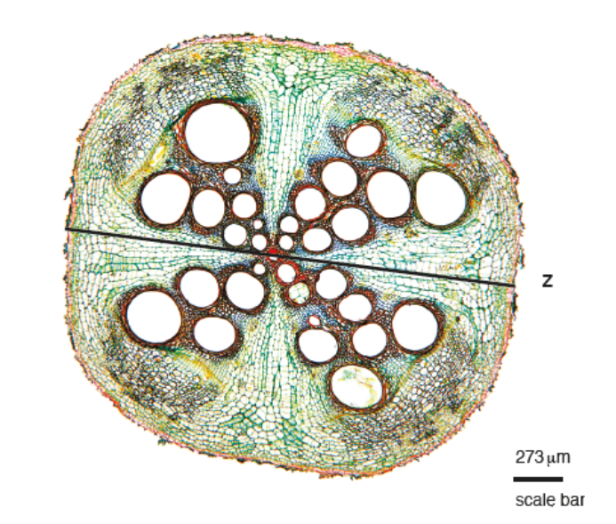
Fig. 3.2

 | (i) | Annotate Fig. 3.2 to describe three observable differences between the root in Fig. 3.2 and the root on slide J1.  - Draw label lines to three features of the root in Fig. 3.2 that are different from the  root on slide J1.  - Label one line Q, label one line R and label one line S.  - Complete Table 3.1 to describe how each feature of the root in Fig. 3.2 differs from the root on slide J1.
feature | root in Fig. 3.2 | root on slide J1
Q  Arrangement of xylem tissue | cross shape | in a ring
R  cortex |  | wider
S  endodermis |  | thinner
 | Pls note that the epidermal layer is both of the same thickness – one cell layer.
number of xylem cells | lesser (about 32) | More (about 40)
pith | Absent | Present
For our ref:
J1 Fig. 3.2
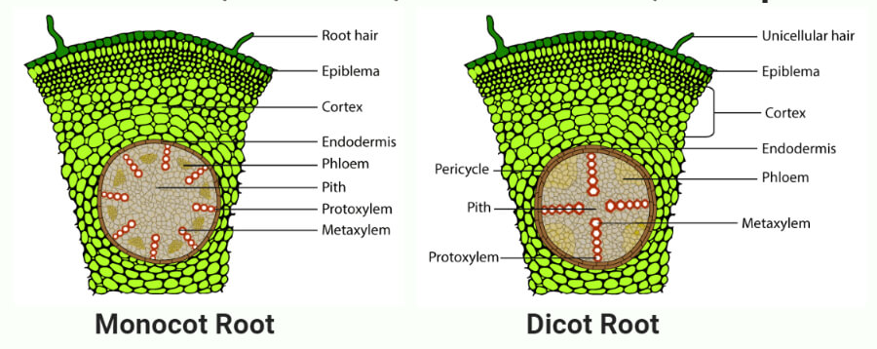

[ACE] [3]
 | (ii) | Use the scale bar and the line Z on Fig. 3.2 to calculate the actual width of the root.  Show all the steps in your working and use appropriate units.  Accepted length of scale bar = 0.6/0.7 cm.  Accepted length of Z = 6.6/6.7 cm.  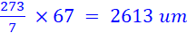 OR 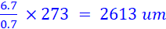
 |  | [MMO] actual width of the root ............. 2613 um............. [3]
(c) | You will be determining the mean width of the three largest xylem cells on slide J1.
 | (i) | Outline how the length of one eyepiece graticule division can be determined under the high-power objective lens, stating any additional pieces of apparatus that you might need.  Show your working in the space below.
- (Place the stage micrometer on the stage, focus and) align the divisions of the eyepiece graticule with those of the stage micrometer.
- (Ensure that both scales are aligned at one end/ at the zero mark) and count the number of eyepiece graticule divisions that correspond with a set number of stage micrometer divisions.
(Knowing that one stage micrometer division is 1 μm, calculate the length of one eyepiece graticule division.)

Under the x40 objective lens,

20 eyepiece graticule divisions = 5 stage micrometer divisions [1]
= 5 x 10 μm
= 50 μm

Thus, length of 1 eyepiece graticule division = 50 μm / 20
= 2.5 μm [1]

length of one eyepiece graticule division ................................... μm [4]

 | (ii) | Identify the three largest xylem cells on slide J1.  Using your answer in (c)(i), determine the width of the first xylem cell.  Determine the widths of the two other xylem cells and calculate the mean width of the xylem cells.  Use the space provided to record your results in a suitable form and show your working in calculating the mean width.
(d) | - You are provided with a sample of plant tissue, which functions as an underground storage organ:  - J2, a cylinder of plant tissue, in a Petri dish labelled J2.  You are required to:  - make a microscope slide of the sample of plant tissue J2  - record observations of the cells  - stain the cells using iodine solution.  Proceed as follows.  1 Label one microscope slide J2.  2 Using a scalpel, cut the plant tissue J2 to show a fresh vertical surface, as shown in Fig. 3.3(a).  3 Cut a wedge-shaped piece of plant tissue so that the thin edge is as narrow as possible, as shown in Fig. 3.3(b). Put the wedge into a clean Petri dish.  4 Use a pipette to add distilled water, W, to the Petri dish to cover the potato wedge.  5 Repeat steps 2 and 3 to obtain at least 5 wedges of plant tissue immersed in W in the Petri dish.  6 Select the wedge of plant tissue with the thinnest edge and place it in the middle of the slide labelled J2.  7 Cut the wedge of plant tissue as show in Fig. 3.3(c) and leave the thinnest piece of tissue on the slide.  8 Put one or two drops of distilled water, W, on to the thin piece of tissue on the slide.  9 Add a coverslip to the slide and use a paper towel to absorb any excess liquid.

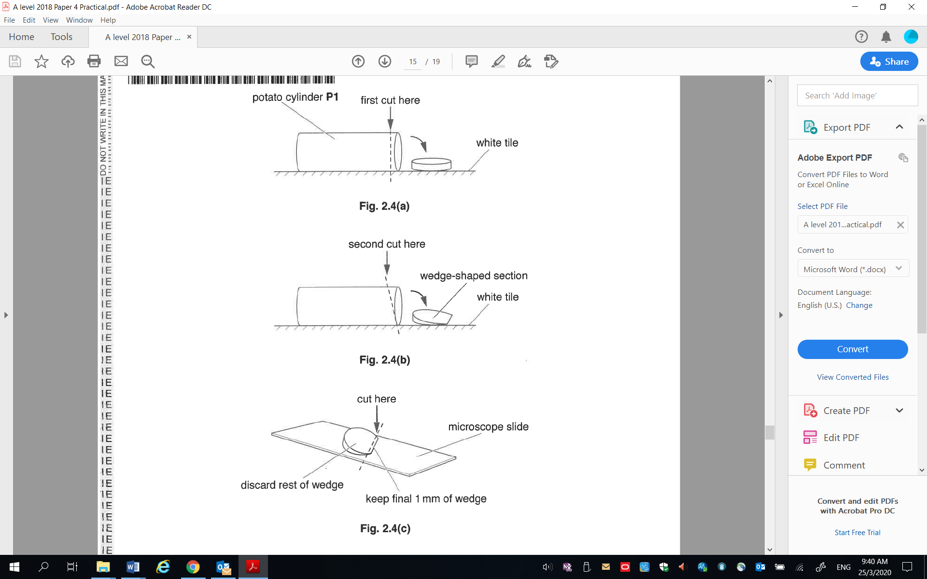
cylinder of plant tissue J2
first cut here
white tile
second cut here
wedge-shaped section
white tile

Fig. 3.3(a)

Fig. 3.3(b)

cut here
microscope slide
discard rest of wedge
keep final 1 mm of wedge

Fig. 3.3(c)

 | 10 Use your microscope, with an appropriate objective lens, to search slide J2 to find three cells that each contains at least three granules. The cells do not need to be adjacent. You will need to adjust the fine focus of the microscope as you search. Ignore granules that may have been released from the cells during slide preparation.
 |  | (i) | Draw the three whole cells that you have selected on slide J2.  Use an appropriate objective lens so that your drawing of each cell can be as detailed as possible.  Labels are not required.
- three whole cells drawn, which occupies at least half of given space, drawn with clean continuous lines
- cells are of irregular/ angular shape + at least 3 granules drawn per cell
- cell wall and starch granules drawn to correct proportion (length of cell corresponds to length of ~ 5 starch).

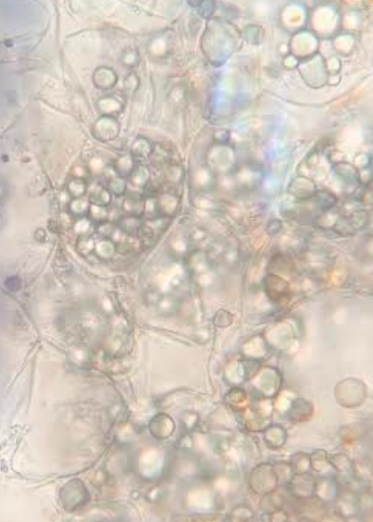
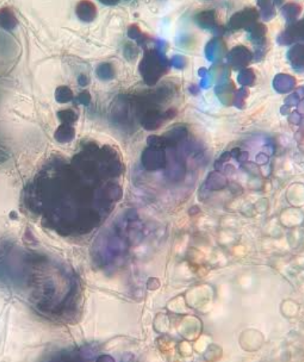

[3]

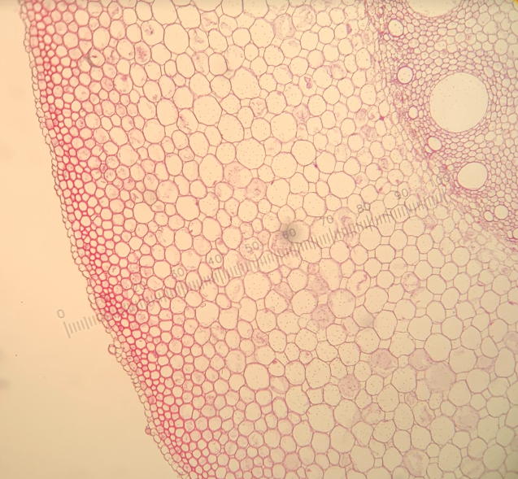

11 Remove slide J2 from the microscope and add a drop of iodine solution to one side of the coverslip. Hold the edge of a paper towel against the opposite side of the coverslip as shown in Fig. 3.4. The iodine solution will spread out under the coverslip.
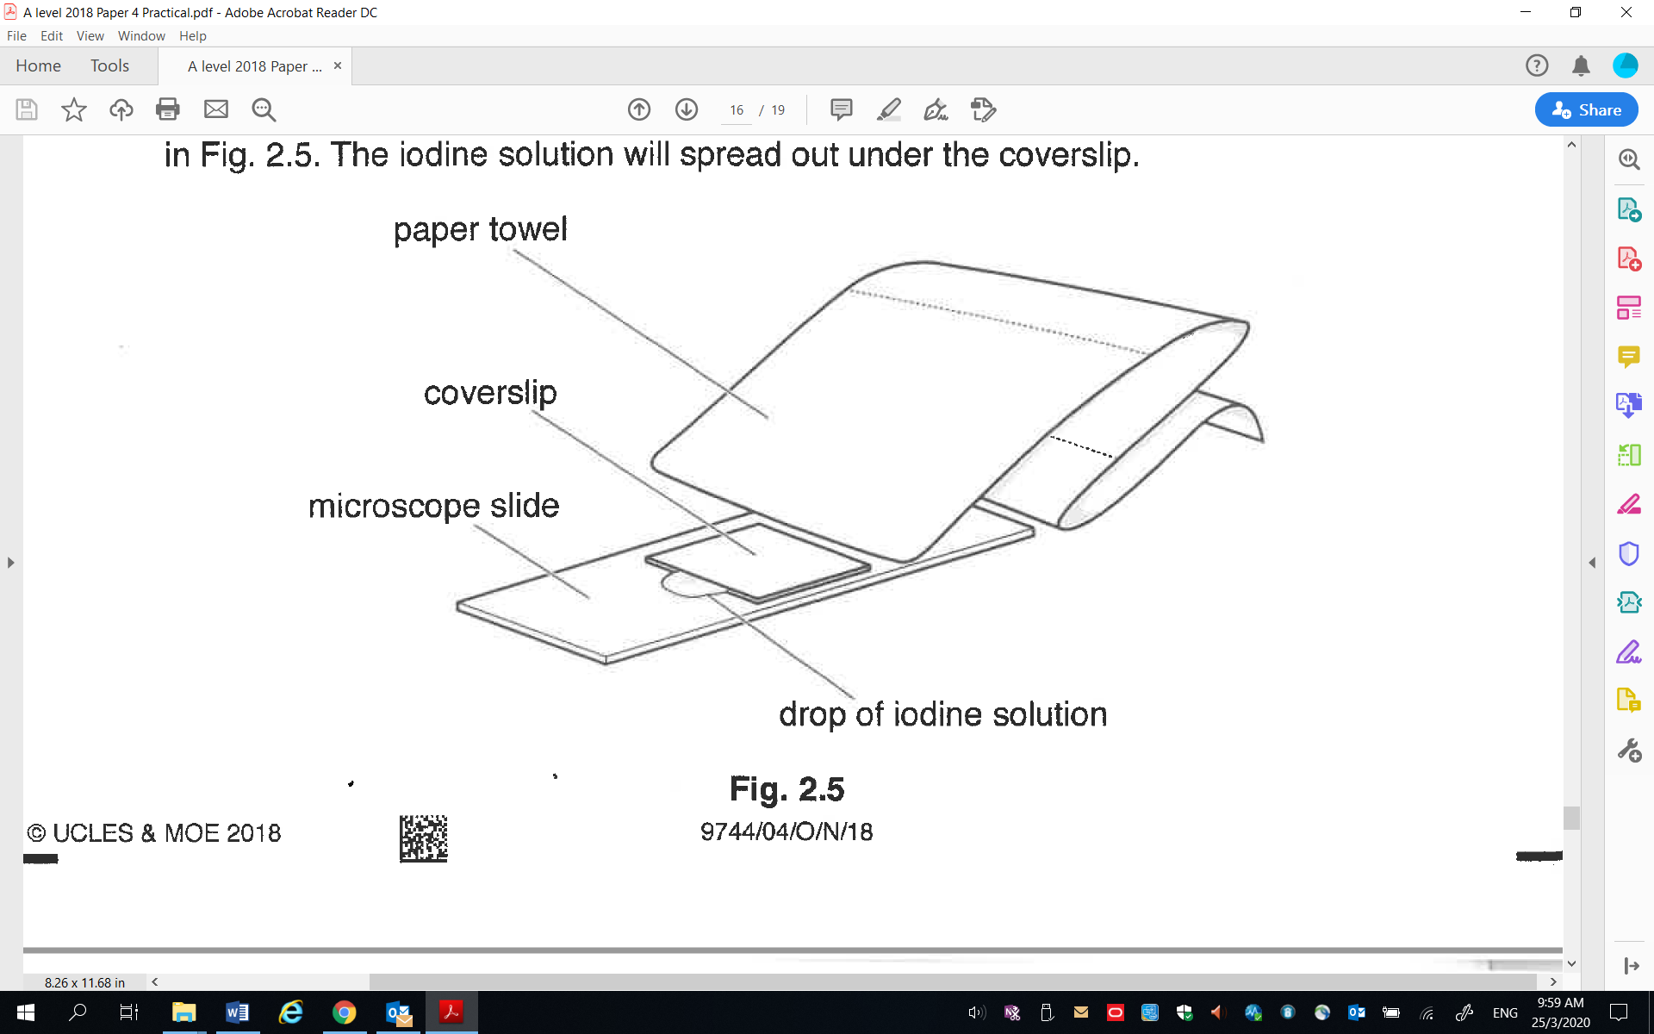
paper towel
coverslip
microscope slide
drop of iodine solution

Fig. 3.4

 | 12 | Observe the cells on slide J2.
 |  | (ii) | Describe the appearance of the cell contents on slide J2. [1]
 |  |  | - all/ numerous starch granules are stained blue-black
 | 13 | Observe the cells in the cortex of the root on slide J1. The cortex is an outer layer of a root, lying below the epidermis but outside the vascular bundles.  Visually compare them with the cells on slide J2 which you observed in (d)(i).
 |  | (iii) | A student proposes the hypothesis that:  the cells in the root cortex on slide J1 are comparable in size to the cells on slide J2.  Outline the key steps which the student can take to investigate this hypothesis. [2]
- Measure the width/ diameter/ size of 20 cells each (Accept: any whole number that is 5 or more) in the cortex region of slide J1, and the cells on slide J2.
- Using the data, conduct a statistical t-test.

 |  | (iv) | Cell size and contents are possible differences between the root cortex cells on slide J1 and the cells on slide J2.  State one other difference that can be observed between the root cortex cells on slide J1 and the cells on slide J2. [1]
- Cells on slide J2 are more irregular/ angular in shape than cells on slide J1 (more circular/ rounder).
- Cells on slide J2 are less densely packed/ presence of intercellular spaces on slide J2, but cells on slide J1 are more densely packed/ absence of intercellular spaces.
[Total: 22]

